**SMART KITCHEN**

**INTRODUCTION:**

**Overview:**

The main theme of our project is to make lives easy in a smart way. This project will let the user know what is happening in their kitchen even when they are away from home. It is not easy for human brain to monitor everything by just remembering, as they are busy engaging in their daily work. One might not be aware of the quantities of the pantry essentials in their homes all the time. This could be a problem if they don’t know when the essentials may run out. So, we thought of designing a smart kitchen which will let the user know the details of the kitchen essentials.

**Purpose:**

The main purpose of this is to reduce the human effort and make life simpler in a smart way. This can also help in protecting if any gas leak occurs at home. The user will be notified when the essentials are about to run out in the jars and also when the gas cylinder is about to get empty.

**LITERATURE SURVEY:**

**Existing problem:**

In reality, no one is really free to randomly check their kitchen like pantry essentials and gas cylinder leaks etc. This could be a problem when the essentials run out and when a gas leak occurs. People may or may not know when the essentials will run out as they work away from their homes. If there is a gas leak at home, that might lead to a major fire explosion.

**Proposed system:**

In the kitchen, all the jars are replaced by smart jars which sends an alert when the jar gets empty or the measured sensor value is below the threshold. These jars communicate with the controller through NRF communication. The cylinder is attached with a leakage sensor that detects the leakage from the cylinder and sends a notification if any leakage is detected. If any leakage is detected the exhaust fans are automatically switched ON. Cylinder weight is also measured and sends an alert when it is empty, based on the empty cylinder weight. All these parameters can be monitored by both Mobile App and Web App.

**THEORITICAL ANALYSIS:**

**Block diagram:**

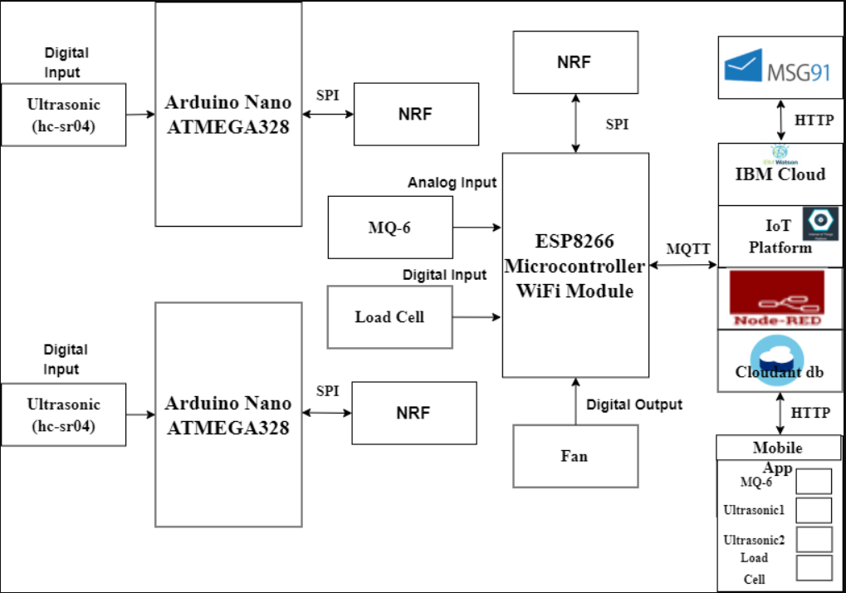

**Hardware/Software Designing:**

* IOT Open Hardware Platforms
* IOT Application Development
* IOT Cloud Platform
* IOT Communication Technologies
* IOT Communication Protocols

**EXPERIMENTAL INVESTIGATIONS:**

To get an idea of how really a smart kitchen looks like, we have referred the below link:

<https://www.boldbusiness.com/digital/smart-kitchen-appliances/>

**FLOWCHART:**

Create Fast2sms account

Create an IBM Watson platform

Create Node-red application

Create an IBM account

Create HTTP requests to communicate with a mobile app

Create a node-red flow to get the data from the device

Code snippet for sending message alerts to the user

Configure the application to receive the data from the cloud

Design your UI to display the quantity of products in the jar

**RESULT:**

Through this, user will get a message to their mobile phone when the pantry is about to get empty and when the gas cylinder is about to get empty. It also notifies the user when there is a gas leakage in the kitchen and turns on the exhaust fans. This can make life easy.

**ADVANTAGES & DISADVANTAGES:**

**Advantages:**

* In today’s fast paced society, this will be more convenient as the user can worry less through this.
* Kitchen management will be easy for the user.
* It is easily manageable just through the phone and safe to use.

**Disadvantages:**

* Not everyone can install this at their homes as it is slightly expensive.
* It is dependant on the internet. Without proper internet connection, they will not work.

**APPLICATIONS:**

* It can be installed in kitchens at home.
* It can also be installed in restaurant kitchens.
* It is mainly useful where there is a use of pantry essentials and gas cylinders.

**CONCLUSION:**

The smart kitchen is a particularly interesting area because the act of cooking varies so greatly between cultures. For those with fast-paced jobs and long commutes, cooking is often unthinkable, for example, whereas others do not go a single day without a home-cooked meal.

**FUTURE SCOPE:**

Smart kitchens are new phase in Internet of things platform. It will be a great initiative as the world is moving towards the technology. People are preferring to make their lives simpler and showing more interest towards these smart appliances.

**BIBLIOGRAPHY:**

No books referred.

**APPENDIX:**

